Grade: 7 Unit: Football Lesson Duration: 38 minutes

SPECIFIC OUTCOMES FROM ALBERTA PROGRAM OF STUDIES | LEARNING OBJECTIVES  (2-3, clear, and measurable)  Students will: | Formative & Summative ASSESSMENTS (How will you know they met learning objectives?)  (Observations, Key Questions, Products/Performances)
A7-5 | Students will demonstrate their ability to throw and receive a football correctly using thumbs in, and tuck catches. | Observation Checklist
A7-2 | Demonstrate special awareness through the running of patterns in order to receive a ball both guarded, and unguarded. | Observation Checklist
LEARNING RESOURCES CONSULTED
MATERIALS/ EQUIPMENT/ SET UP
Footballs
Field
PROCEDURE
Introduction (10 min.):
Students will be expected to change out, and then get into their squads to await further instruction for the lesson. Before Starting off the lesson I will introduce the students to the 3 different patterns that we are going to practice within todays lesson these 3 passing routes will be crucial as we are going to spend the rest of the class working on them after a brief warm up period. Show them how I want the routes ran 1 person snapping the ball to the QB, and then the third player running the play.
3 Routes:
- Fly (A straight route)
- Slant (A straight route which goes off left or right)
- Hook (A straight route that involves turning backward to face the QB)
Body (25 min.):
What is the teacher doing?

Learning Activity #1: Octopus or 1 song Jog 5 minutes
In octopus tag students will engage in a game of octopus tag where they run from one side of the gym to the other avoiding getting tagged, and if you get out you will be required to do some type of exercise every round so that this doesn’t become a game of students simply sitting out, or getting tagged so they can sit and talk with their friends.

A one song jog has students go around the outside lines in the gymnasium and jog for the duration of the song, if students are being off task and messing around early on in the lesson as a sort of management tool you could increase the length of the song, and let the students know why you increased it.

Learning Activity #2: Running patterns 20 minutes
Students will be required to get into groups or 3-4 no less. Once I have confirmed the student groups I will hand out a football to the different group. The students will then line up in their groups utilizing the space provided. I will join a group as a thrower and demo the activity. The first pattern we run will be the fly. I will review what the fly is by asking a student and then have them run the pattern throwing the ball for them to catch it. I will then perform the route myself asking a student to throw it to me and once the class understands the activity allow them to try the activity for him or herself. Patterns will be added as students begin demonstrating familiarity with the current pattern.

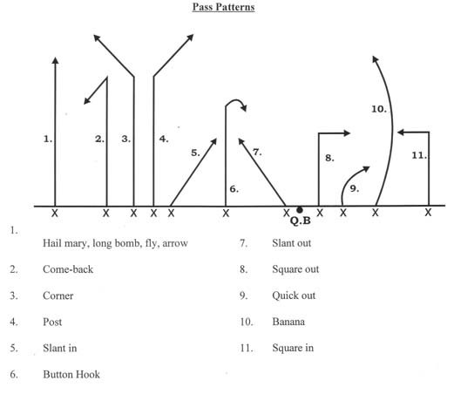

Closure (4 min.): * Connect your closure with learning objectives*
As a class we will discuss when different patterns may be better to use than others, and if there are ways we could easily form new patterns using the ones we looked at this class.
10 Key questions to review your plan:
- What will my classroom/ teaching area look like when I begin to teach?
- How will I interest the students on the lesson questions/ topic?
- At what part of the lesson will I assess formatively? Summatively?
- Have I clearly planned how I will transition from each part of the lesson (e.g. intro to activity 1)
- Have I given thought to what approach to use in each activity? (e.g., direct instruction vs. group work)
- Do I have enough detail in my activity descriptions to really understand what I will say, do, and assess?
- Have I considered how my students will react to each activity? Any special learner considerations?
- Do I know what evidence I am looking for as I assess formatively (e.g.- as you observe students working- what are you looking for? As you question the students- what types of answers are you hoping to receive?)
- Does my closure solidify the key points to the lesson?
- Do I connect my closure to the lesson objectives?

Lesson Reflections (After you teach):
What went well:

Students were able to learn all 3 of the routes I had planned on teaching, and had ample time to practice each route.

What can be improved upon:

Sometimes when performing the route the QB was very unsure of when exactly they should be throwing, when demoing routes for the class I may have wanted to made it more clear when exactly students should be throwing the football, but to that some point this is also good to leave as a self discovery type part of the skill.

Describe how the students met your lesson objectives:

Students demonstrated an ability to run the route, and this was required for the next day’s lesson in which routes and strategy are needed in order for students to play the 5 on 5 football games.

